**Beardsley, Aubrey Vincent (1872-98)**

Aubrey Beardsley was an English illustrator of the late Victorian period. His fluid, sinuous illustrations were influenced by Japanese prints and by the curvilinear ART NOUVEAU style. Beardsley was a prominent member of the Aesthetic Movement, a progressive group of artists and writers who pursued the cause of art for art’s sake and rejected the repressive constraints of Victorian society. Beardsley’s drawings revelled in the decadent and the erotic, and his public persona was that of a flamboyant dandy.

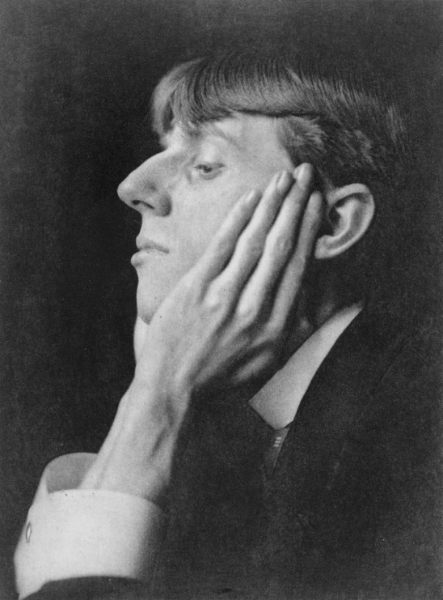

Aubrey Beardsley c.1895

<http://en.wikipedia.org/wiki/File:Aubrey_Beardsley_ca._1895.jpg>

Beardsley was born in Brighton, but his father was forced to move the family to London in 1883 after losing his inherited fortune. His mother taught piano lessons to supplement their income. Both Beardsley and his sister, Mabel, appeared in public as musical and artistic prodigies. In 1888 Beardsley joined an architect's office, but the course of his career changed in 1891 when, uninvited, he visited the studio of the Pre-Raphaelite painter Sir Edward Burne-Jones (1833-1898). Impressed by Beardsley's drawings, Burne-Jones suggested he attend night classes at the Westminster School of Art. This was the only formal training Beardsley ever received.

Beardsley’s major creative output was concentrated into six years of intense activity. He made his name by illustrating J. M. Dent's deluxe edition of Sir Thomas Malory's *Le Morte d'Arthur* (1893-4), and produced illustrations and covers for numerous books and periodicals. Executed in ink, his drawings contrasted flowing, sinuous lines with large expanses of black; they also juxtaposed areas of intense detail with pure white space to produce an effect that was both striking and highly decorative. Beardsley was greatly influenced by the languorous, curvilinear style and erotic charge of Art Nouveau. Like other members of the Aesthetic Movement, he also admired the Japanese woodcuts that became popular in late Victorian Britain, emulating their bold sense of design and use of asymmetry.

Beardsley formed an uneasy alliance with Oscar Wilde, the doyen of Aestheticism. In 1893, Wilde's scandalous play *Salomé* was published in France. Beardsley was commissioned to illustrate the English edition the following year. His lyrical images, laced with mordant eroticism, made him notorious within the Victorian art world. Like Wilde, Beardsley effected the persona of a dandy, extravagant in dress and manner.

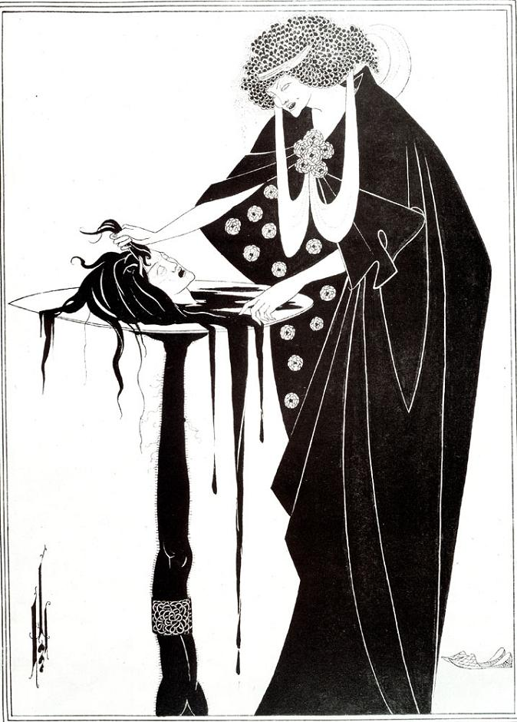

Aubrey Beardsley, *The Dancer's Reward*, 1893

<http://www.artinthepicture.com/paintings/Aubrey_Beardsley/The-Dancers-Reward/>

Venturing into publishing, Beardsley co-founded a quarterly periodical named *The Yellow Book* with the expatriate American author Henry Harland. Beardsley served as art editor for the first four editions, producing the cover designs and many illustrations. Following Wilde's arrest for homosexual offences in 1895, Beardsley was dismissed from his post, but he was soon approached by the publisher Leonard Smithers to create a new journal, *The Savoy*. He used this outlet to publish his erotic tale *Under the Hill*. Smithers continued to publish works illustrated by Beardsley, including editions of *The Lysistrata of Aristophanes* (1896), Pope's *The Rape of the Lock* (1896) and Ben Jonson's *Volpone* (1898). Smithers also published Beardsley's *A Book of Fifty Drawings* (1897), the first collected album of his work. Mischievous by nature, Beardsley was obsessed with eroticism and grotesquery. Many of his later drawings featured exaggerated phalli, revealing the influence of Japanese shunga images.

Beardsley's prodigious talents were curtailed by illness. He had suffered from tuberculosis intermittently from the age of nine and by 1896 he had become an invalid. Realising his demise was imminent, he converted to Catholicism and begged Smithers to destroy his ‘obscene’ drawings. Beardsley travelled to Menton in the south of France and died of tuberculosis on 16 March 1898, aged only 25.

**List of works**

Beardsley, A. (1897)*A Book of Fifty Drawings*, London: Leonard Smithers. (This volume was the first collected album of Beardsley’s work).

Beardsley, A. (1899)*A Second Book of Fifty Drawings*, London: Leonard Smithers. (A second collected album of Beardsley’s work).

Harris, B. (1984) *Collected Drawings of Aubrey Beardsley*, London: Random House. (An exhaustive compendium of Beardsley’s drawings, featuring recollections by his contemporary Arthur Symons).

Mallory, T. and Beardsley, A. (1972) *Beardsley's Illustrations for Le Morte d’Arthur*, New York: **Dover Publications.**  (All of Aubrey Beardsley's illustrations for Malory's *Le Morte d’Arthur* are reproduced together with selected pages from the text).

**References and further reading**

Calloway, S. (1998) *Aubrey Beardsley*, New York: Harry N. Abrams. (A comprehensive, well-illustrated biography that explores the diverse influences that were synthesised into Beardsley’s work, from Ancient Greek vases to Japanese prints).

Colvin, D. (1998) *Aubrey Beardsley: a slave to beauty*, London: Orion Media. (A lavishly-illustrated biography, this volume sheds light on Beardsley’s relationships with friends and contemporaries).

Snodgrass, C. (1995) *Aubrey Beardsley: Dandy of the Grotesque*, Oxford: Oxford University Press. (An intriguing study that examines the structure of Beardsley's drawings and relates his work to his dandy persona).

Wilson, S. and Zatlin, L. (1998) *Aubrey Beardsley: a centenary tribute*. Tokyo: Art Life Ltd. (An exhibition catalogue with text in English and Japanese, featuring over 180 of Beardsley’s illustrations).

Zatlin, L. (1990) *Aubrey Beardsley and Victorian Sexual Politics*. Oxford: Oxford University Press. (A study of Beardsley’s erotic subject-matter. The book analyses the influence of earlier pornographic artists and Japanese prints, arguing that Beardsley was concerned with dismantling Victorian sexual stereotypes).